**How To Run a HTML Project Using http-server**

* STEP 1 – Install node.js (you can download this at nodejs.org)
* To check if it’s installed, you can type “node -v” in BASH to check the version number.
* STEP 2 – Using your preferred text editor, edit a html file named firstHTML, and save it.
* STEP 3 – Open Bash/Git Bash
  + For Mac users, this the application called Terminal in the Utilities folder in the Applications folder.
  + For Windows users, you’ll have to download Git Bash from git-scm.com
* You’ll know if you’ve opened bash if you see the dollar sign command [seen in the first screenshot]
* STEP 4 – Type in “npm install -g http-server” into the terminal
* STEP 5 – cd to your project folder
* You can do this by typing “cd “ with the space included in the terminal, followed by the path of your file (firstHTML in this example)
* An easier way to do this is by typing cd, and then dragging your file to the terminal. It will add the file’s path automatically.
* STEP 6 – Run http-server
* Do this by typing “http-server firstHTML/” in the terminal.
* 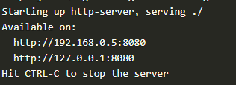You should see something like this:
* STEP 7 – Opening the URL in a browser
* Open a browser and type in <http://localhost:8080> in the address bar. You should be able to see your HTML file in the browser. You’re done!